 Sample Deal Sheet March 17, 2024
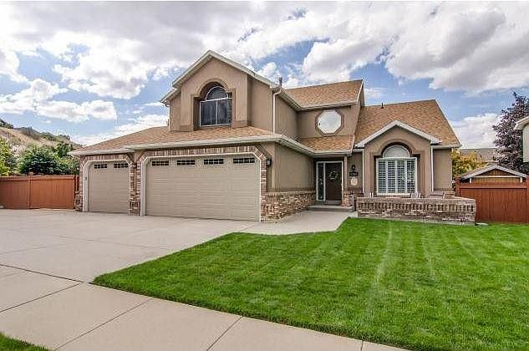
Zillow Link

Property | Loan
Address: 6736 S Benecia Dr, Cottonwood Heights, UT 84121  Zillow estimate: $938,600 Type: Single family  Configuration: 5 bedrooms, 4 bath  Square footage: 2,617 Price/square foot: $359  Condition: Very good Year built: 1993 | Purpose: Cash out  Loan amount: $650,000  Term: 2-years  Rate: 10% (net to investor)  Prepayment penalty: Yes; 1% of loan amount  Monthly interest payment: $5,416.67

Borrower | Underwriting
Address: Bill & Sally Smith  Credit score: NA  2023 AGI: $114,138 2022 AGI: $109,394  Debt to income: 33%  Exit strategy: Refinance  Condition: Very good Year built: 1993 | Appraisal type: Broker’s opinion  Broker’s price opinion: $945,000  Net equity value: $295,000  Loan to value: 68.6%  Net equity percent: 31.4%  Prepayment penalty: Yes; 1% of loan amount

Additional Notes
Bill has worked for the Salt Lake School District for 14 years; Sally is a self-employed hairdresser. The loan proceeds will be used to finish repairs to a rental property they own in South Jordan, which they plan to sell next year. Their net worth statement reflects $987,000, which includes various retirement accounts.

